1: Project List

In the page you will see a list of projects with information like latest commit date, message, and revision number.

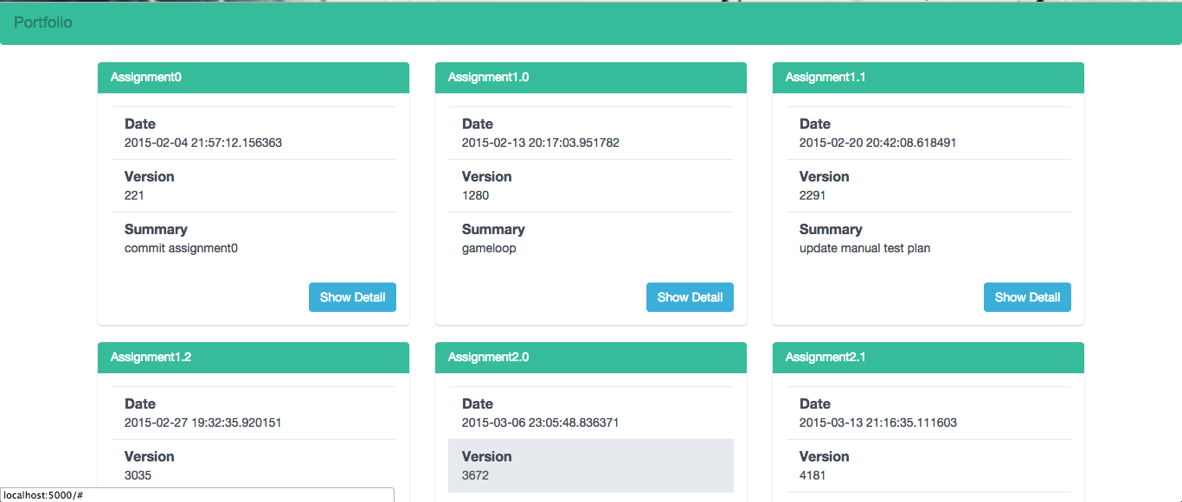

2: Project Detail

You can click “Show Detail” to see more information, including files list and comments, about specific project.

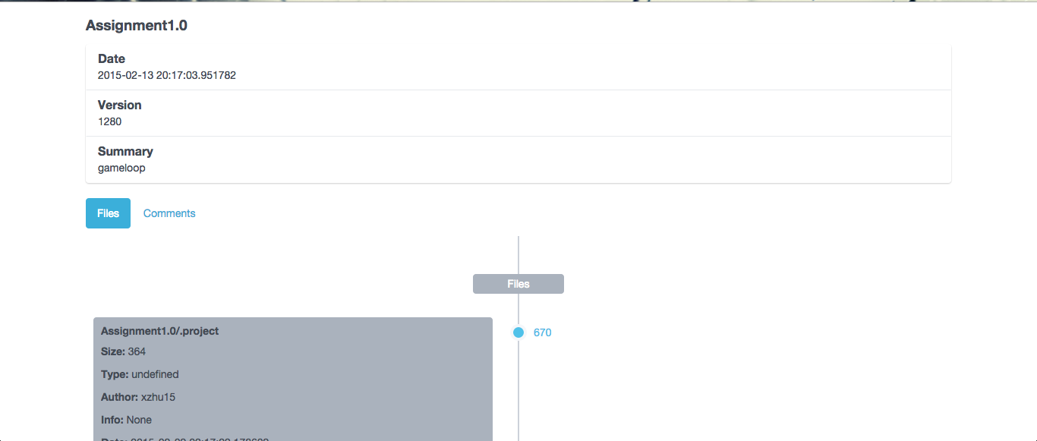

A: File View

For the files list, you can see a list of files in the project ordered by revision number.

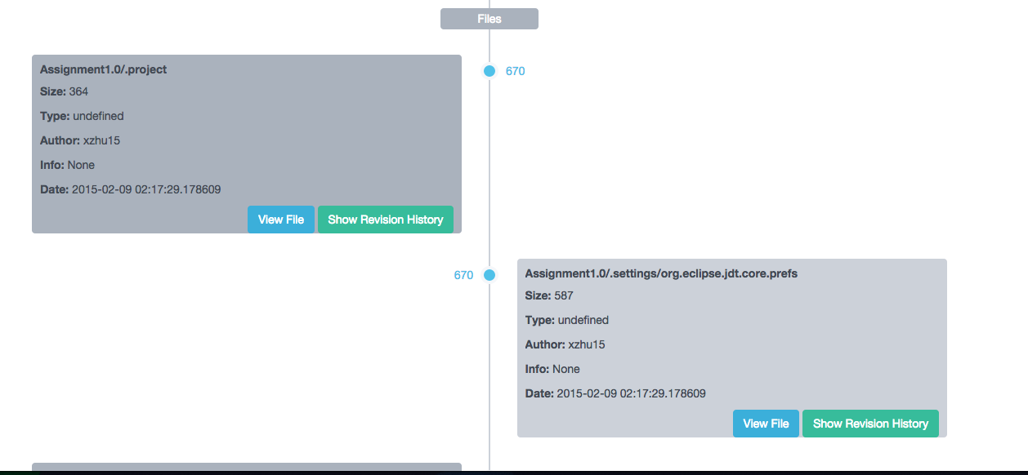

You can click “View File” to see the detail of each file

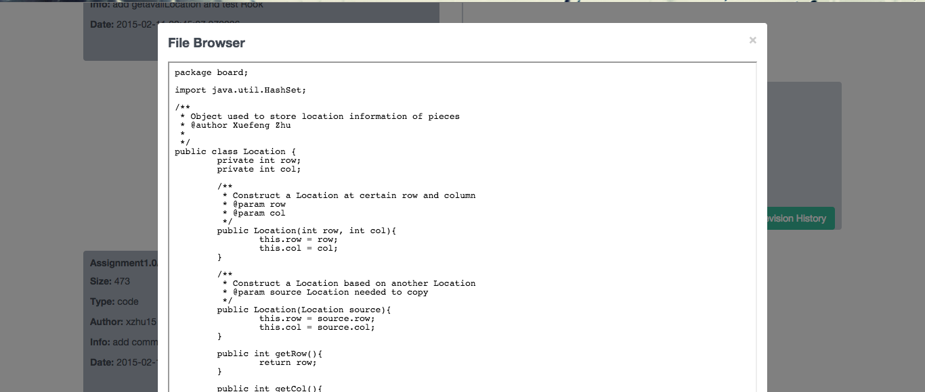

You can click “Show Revision History” to a list of revision history ordered by revision number.

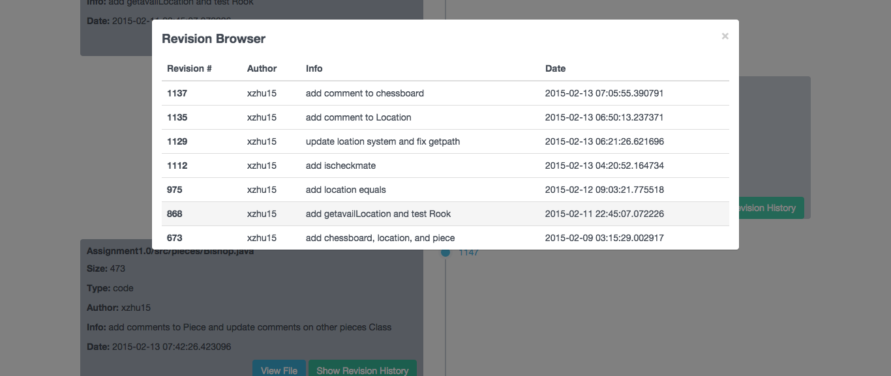

B: Comment View

You can make comments by enter your name and content, and click the “Submit”. For example, enter “Frank” and “Nice work”. Click “Submit”

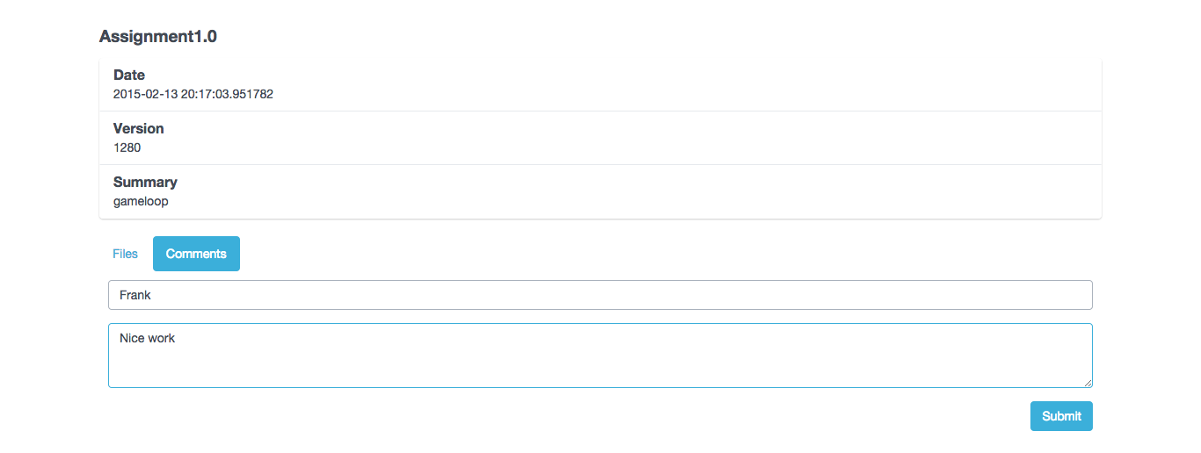

You will be able to see

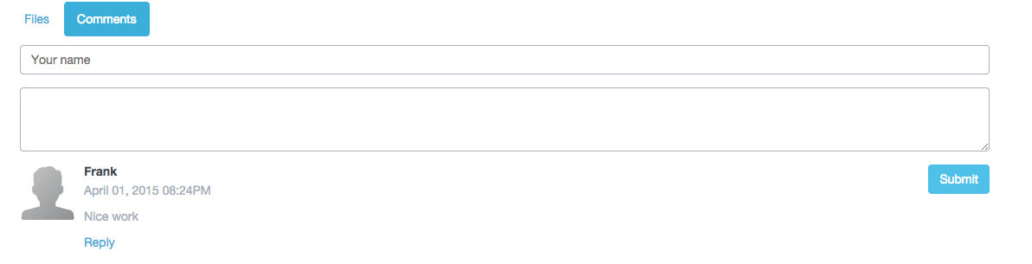

You can reply to others’ comments by click “Reply”

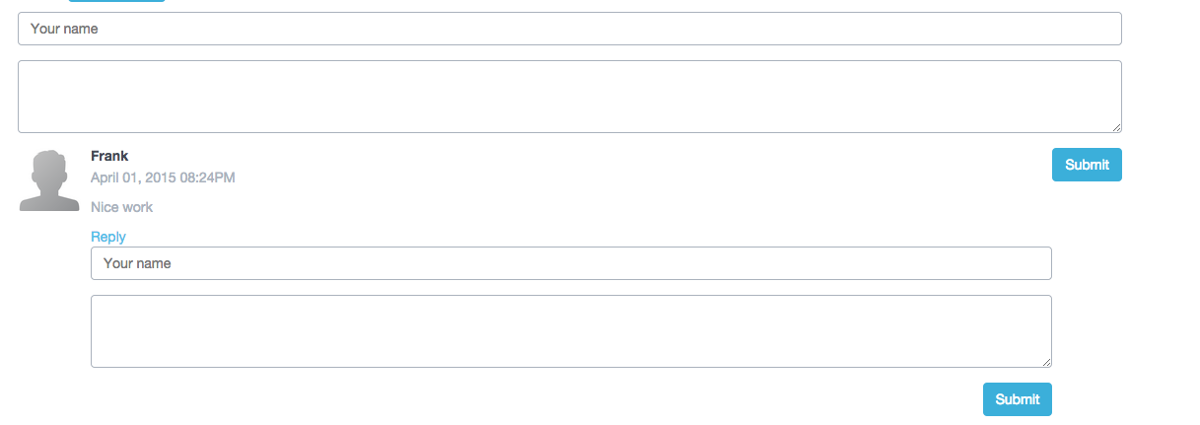

Same as making a new comment, you can just enter the name and content, and click “Submit”

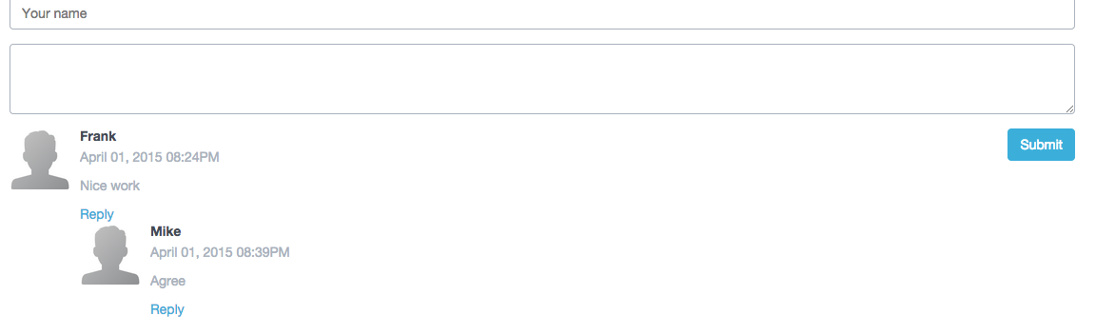

There is also comment filter built in. Bad words will be filtered out .

For example, words like “Damn” will be replaced by “bi”

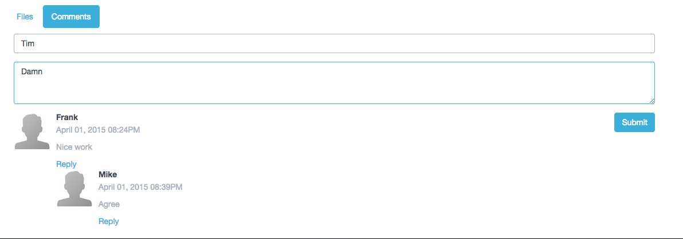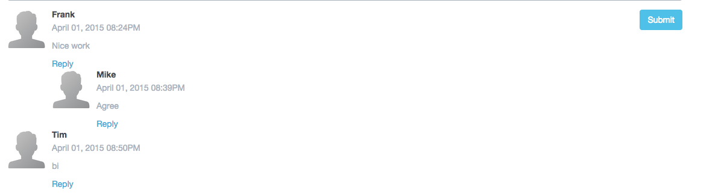

Cross-site Scripting Attacks Prevention

Evil comment intended to attack other users will be automatically escaped.

